Student’s name | …………………………………………………….…… | Grade | 3
Subject | Computer | Week No. | 10
Lesson Title | Loops | Unit | 4
Worksheet No. ( 9 )
Instruction: Select the correct answer from option A-C.

1.Which of the following does not belong to scratch?
a. Pencil tool b. Sprite c. Code
2. Which library allows us to choose a backdrop?
a. Pencil tool b. Sprite c. Code
3. Which option will move the sprite in a forward direction?
a. 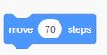 b.  c. 
4. Which option will move the sprite in a backward direction?
a.  b.  c. 
5. Which option allows us to change the colour of the backdrop?
a. 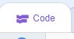 b. 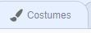 c. 